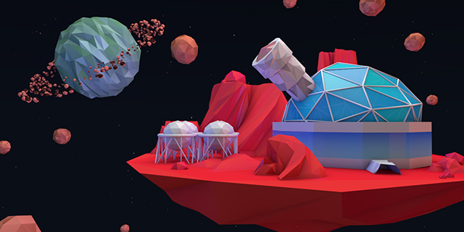Texture Research

Low Poly – So to start with I’m going to be looking for good styles that can fit low poly.

* Here (below - right) we can see an alien structure which is in high definition however I wanted to capture the feeling of how the building looks like it’s almost alive as if the power that runs through it is also keeping it physically alive.
* 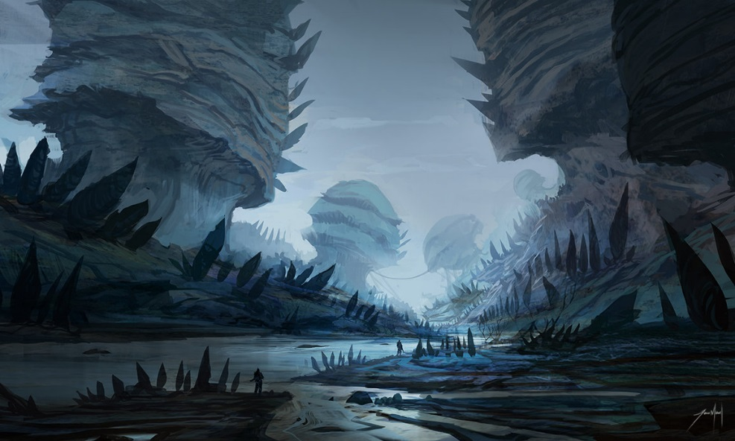Below (left) we have a very sharp and dangerous environment made by aliens.
* 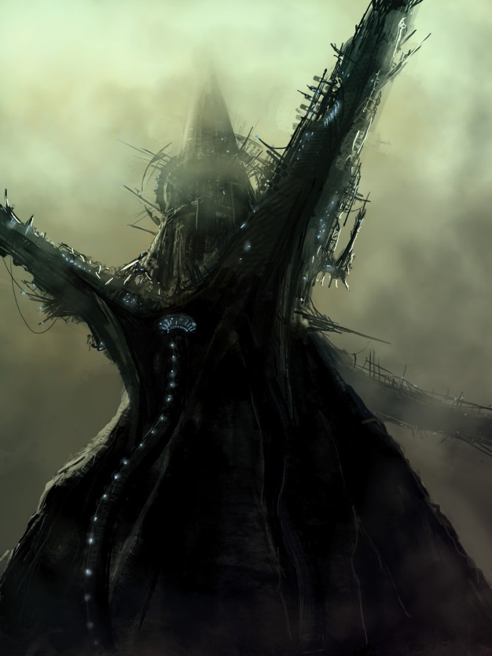I wanted to try and combine this sharp feeling with the structures made

Since we are restricted to low poly models we will need to make it appeal to the players whilst trying to capture these emotions, so I found some ideas of actual low poly appearances. This was more for the learning of the different techniques of creating good low poly textures.

